**UML diagram for ClimeMate app:**

1. Activity Diagram:

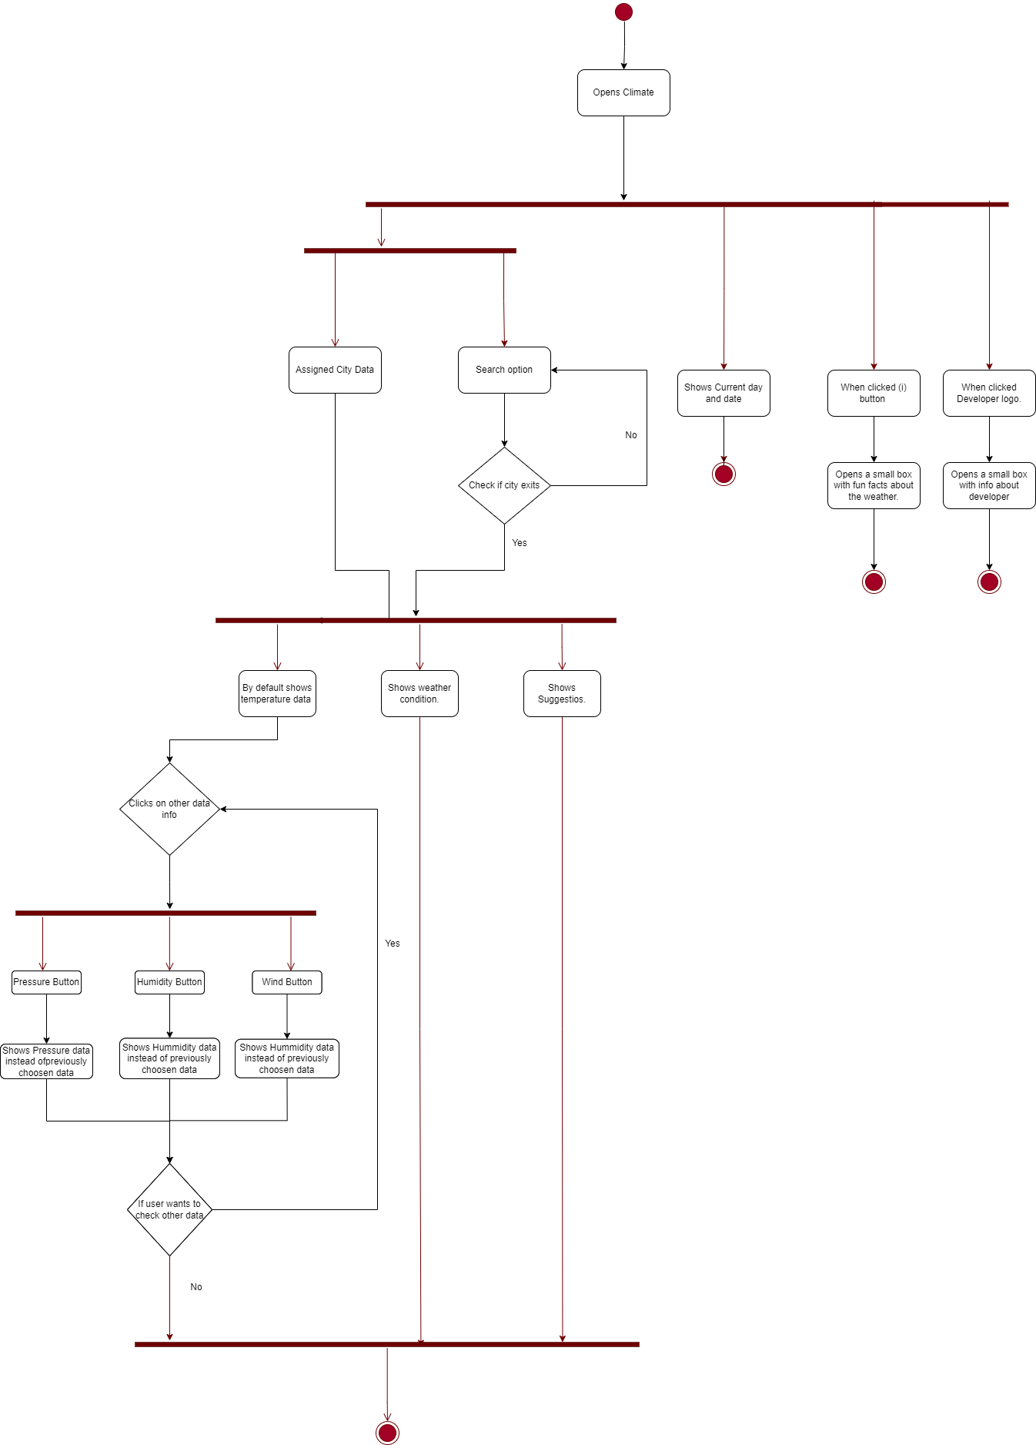

2. Sequence Diagram:

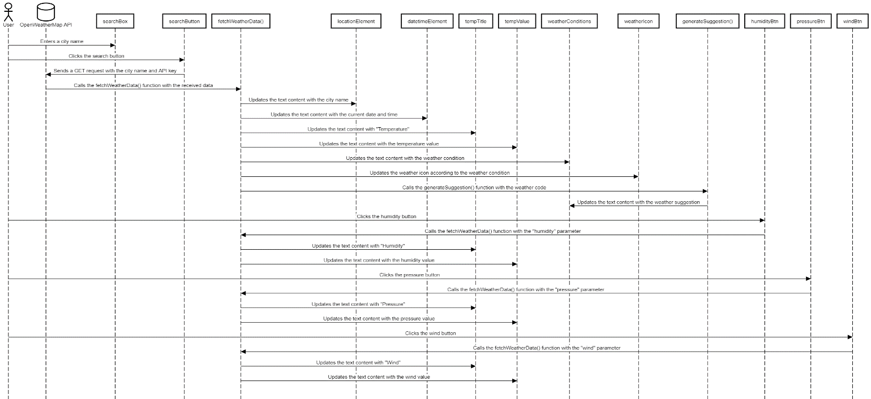

3. Deployment Diagram:

